**PROCESSORS**  
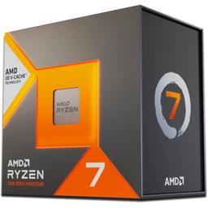

AMD Ryzen 7 7800X3D 4.2 GHz 8-Core Processor - 19,999

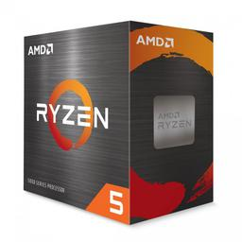

AMD Ryzen 5 5600X 3.7 GHz 6-Core Processor – P8,900

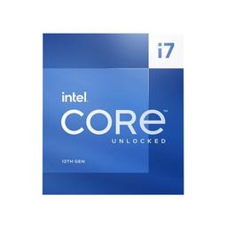

Intel Core i7-13700K 3.4 GHz 16-Core Processor – P 21,800

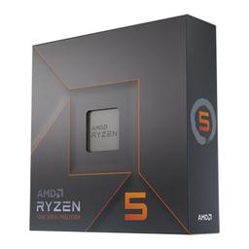

AMD Ryzen 5 7600X 4.7 GHz 6-Core Processor - P 13,220

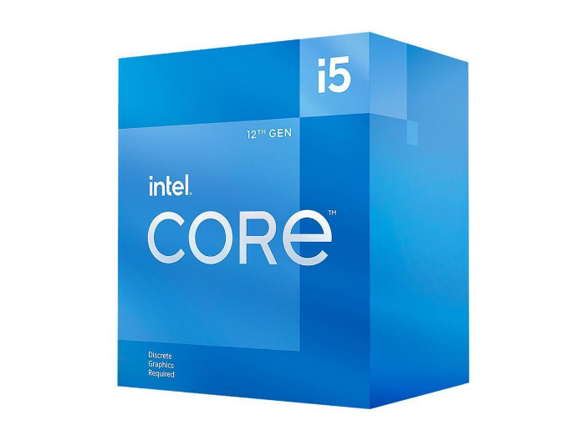

Intel Core i5-12400F 2.5 GHz 6-Core Processor – P 8,399

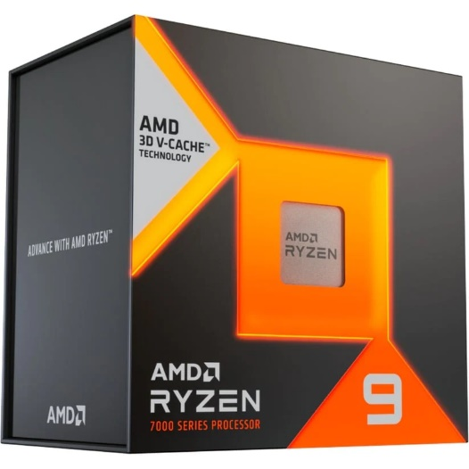

AMD Ryzen 9 7950X3D 4.2 GHz 16-Core Processor – P 33,299

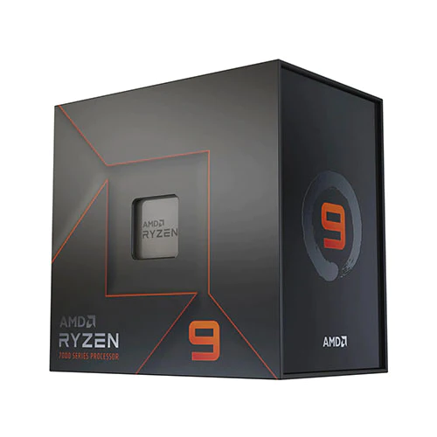

33,167AMD Ryzen 9 7900X 4.7 GHz 12-Core Processor – P 21,599

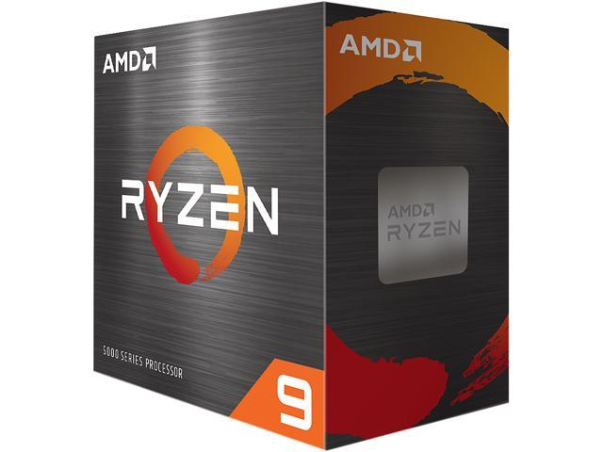

AMD Ryzen 9 5900X 3.7 GHz 12-Core Processor – P 16,530

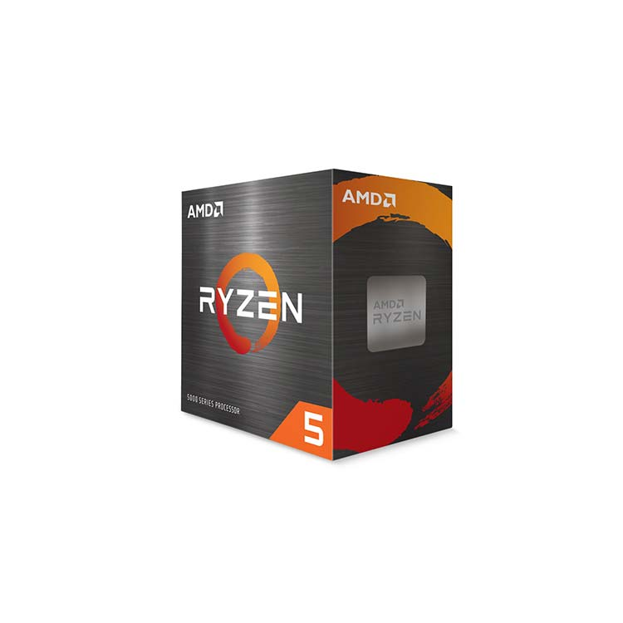

AMD Ryzen 5 5500 3.6 GHz 6-Core Processor – P 6,680

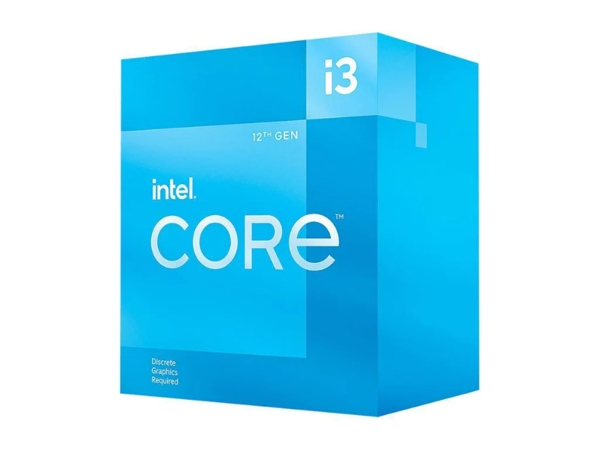

Intel Core i3-12100F 3.3 GHz Quad-Core Processor – P 5,699

**STORAGE**

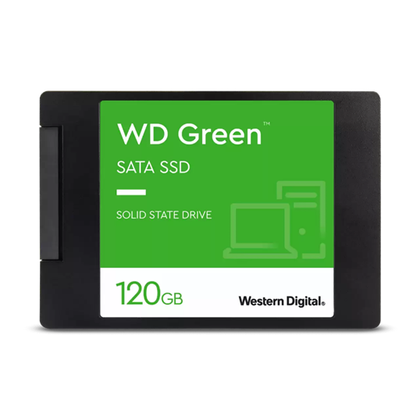

WESTERN DIGITAL 480GB GREEN 2.5" (WDS480G3G0A) Solid State Drive -P2,100

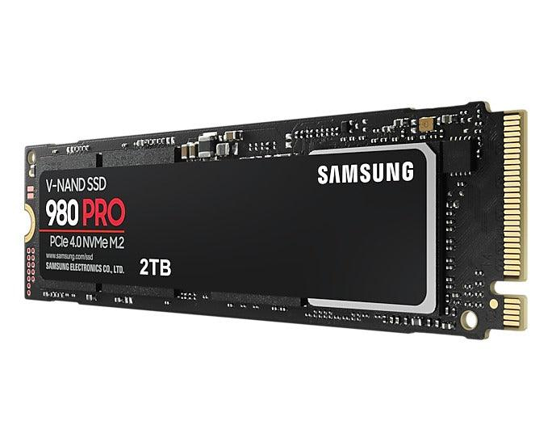

Samsung 980 Pro 2 TB M.2-2280 PCIe 4.0 X4 NVME Solid State Drive – P9,999

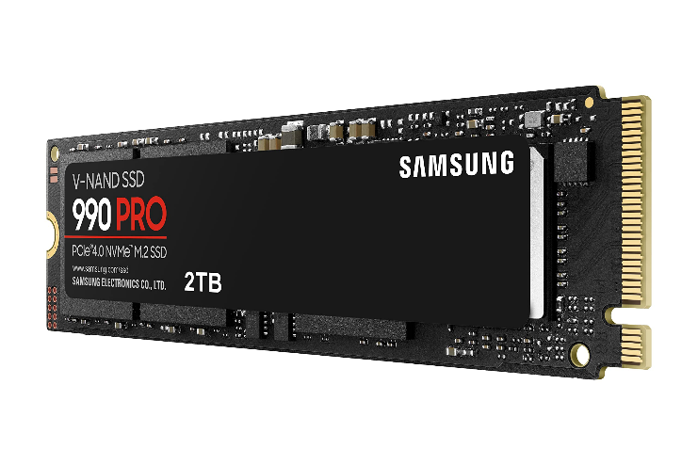

Samsung 990 Pro 2 TB M.2-2280 PCIe 4.0 X4 NVME Solid State Drive – P 12,599

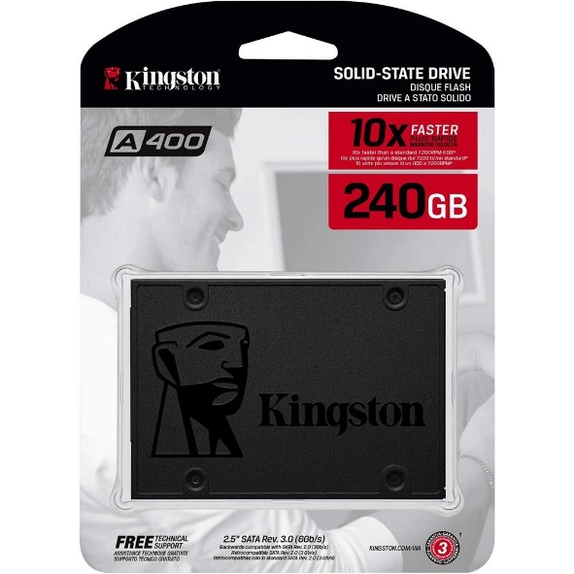

Kingston A400 240GB 2.5" Solid State Drive – P 1,200

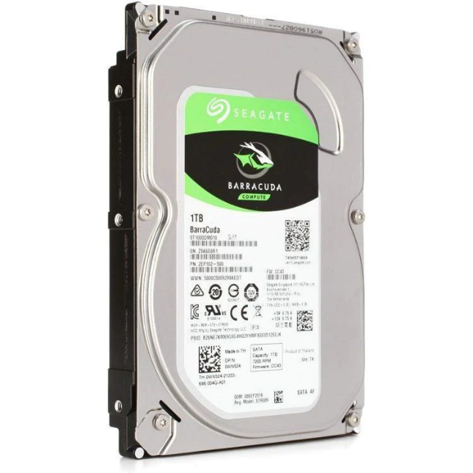

Seagate Barracuda 1 TB 3.5" 7200 RPM Internal Hard Drive – P2,100

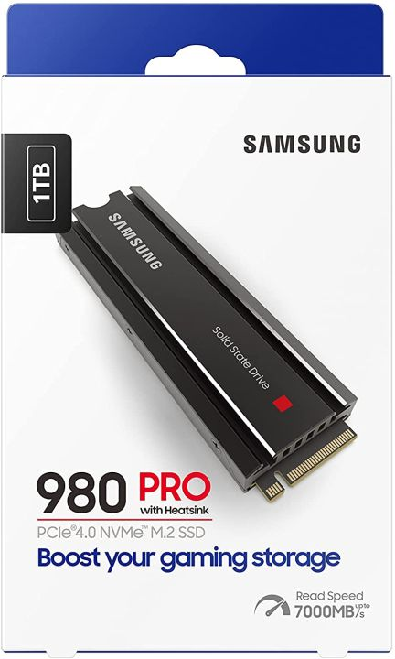

Samsung 980 Pro w/Heatsink 1 TB M.2-2280 PCIe 4.0 X4 NVME Solid State Drive – P6,200

**GPU/VIDEO CARD**

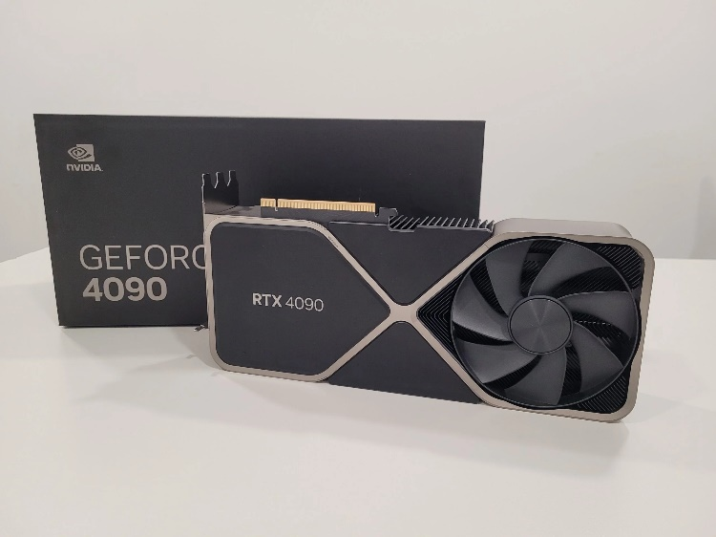

NVIDIA Founders Edition GeForce RTX 4090 24 GB Video Card – P135,810

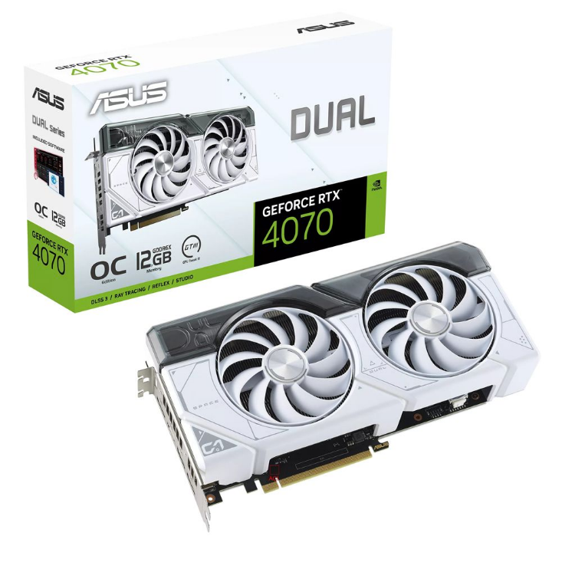

Asus DUAL OC GeForce RTX 4070 12 GB Video Card – P42,300

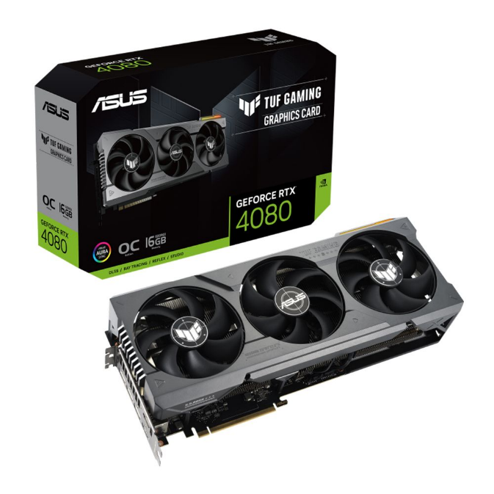

Asus TUF GAMING GeForce RTX 4080 16 GB Video Card – P81,399

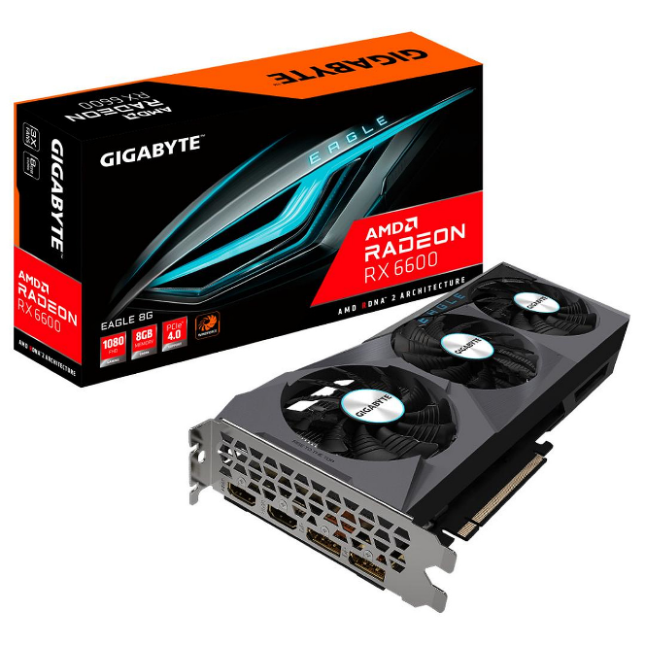

Gigabyte EAGLE Radeon RX 6600 8 GB Video Card – P13,500

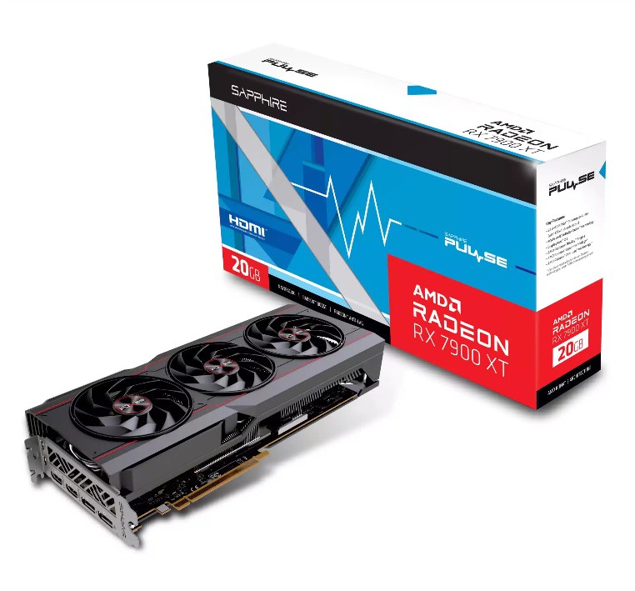

Sapphire PULSE Radeon RX 7900 XT 20 GB Video Card – P53,999

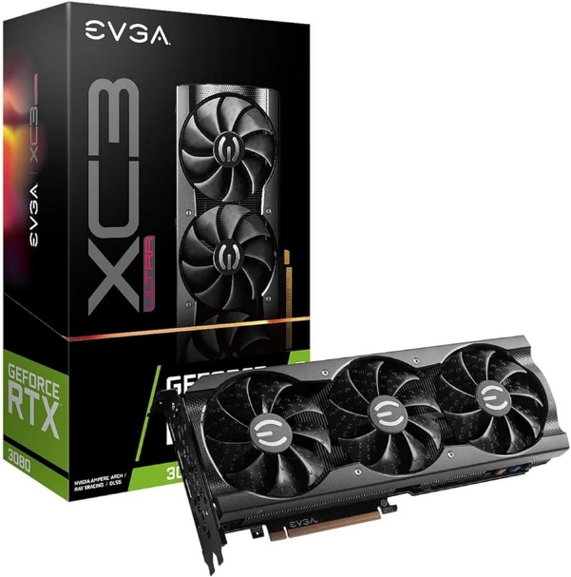

EVGA FTW3 ULTRA GAMING GeForce RTX 3080 10GB 10 GB Video Card – P50,499

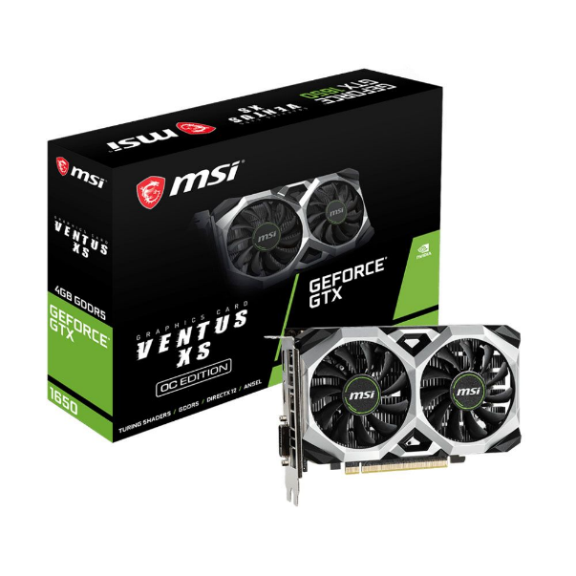

MSI Ventus XS OCV1 GeForce GTX 1650 G6 4GB Video Card – P9,899

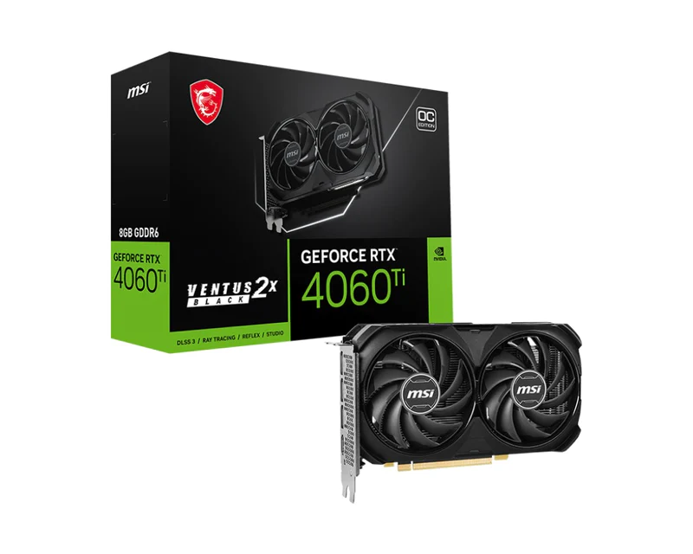

MSI GeForce RTX 4060 Ti Ventus 2X Black 8GB OC GDDR6 Graphics Card – P 30,950

**RAM/Memory**

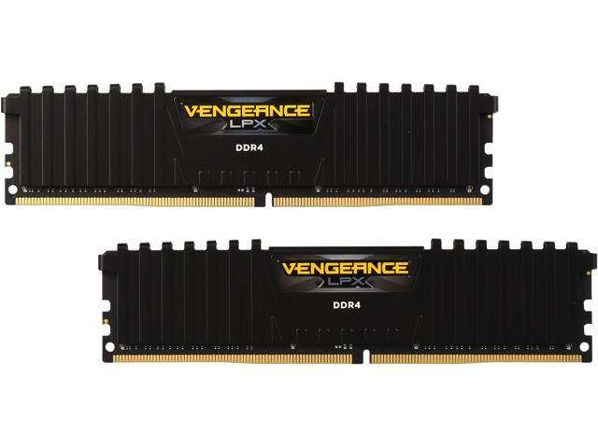

Corsair Vengeance LPX 16GB (2x8GB) DDR4-3200 CL16 Memory – P 3,100

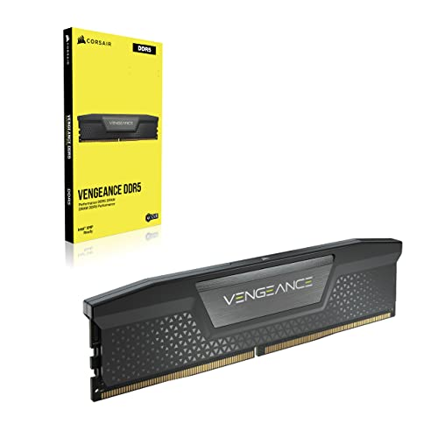

Corsair Vengeance 32 GB (2 x 16 GB) DDR5-5600 CL36 Memory – P 9,200

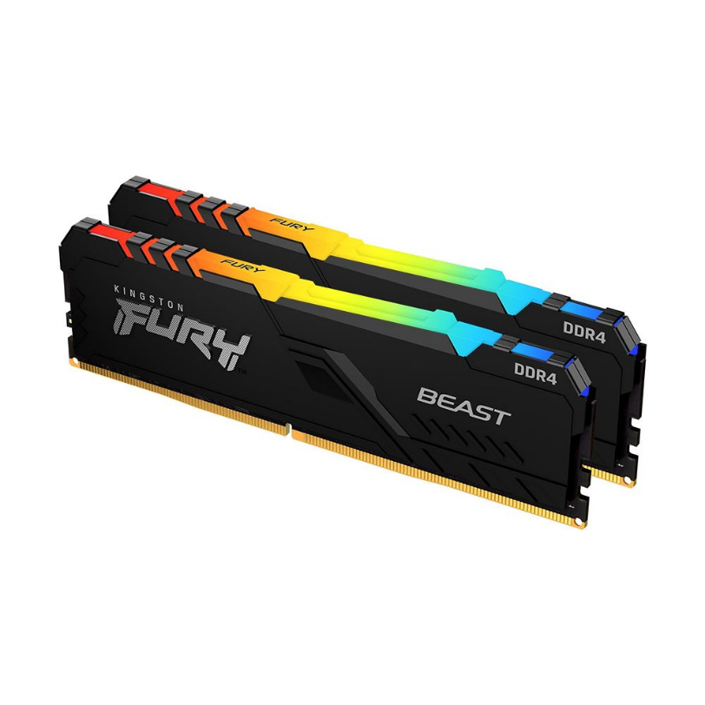

Kingston Hyperx Fury RGB 16GB (8GB x 2) DDR4 3200MHz – P3,500

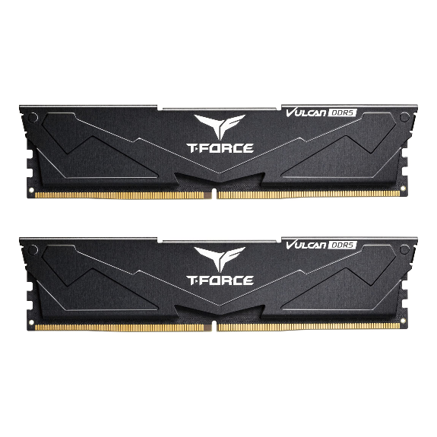

TEAMGROUP T-Force Vulcan 32GB (2x16GB) DDR5-6000 CL38 Memory – P 7,899

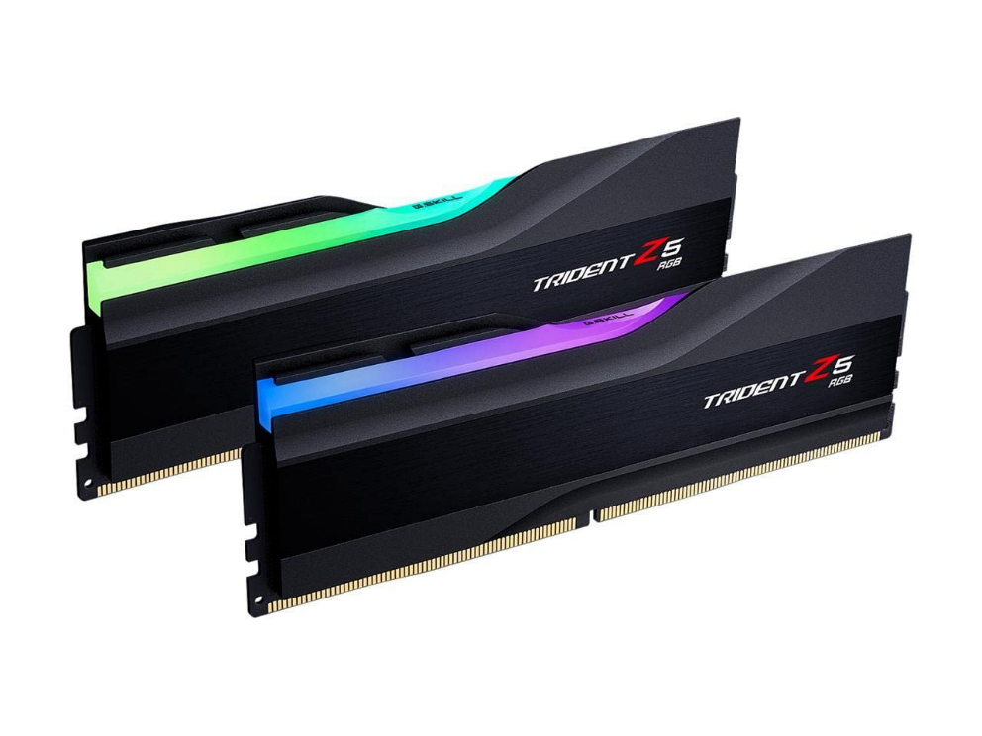

G.Skill Trident Z5 RGB 32GB (2x16GB) DDR5-6400 CL32 Memory – P7,950